CHAPTER 21 - Information Security and Counterintelligence

OBJECTIVES
Provide important definitions related to information security and counterintelligence
Explain the difference between "counterintelligence" as used in the private sector versus the federal government sector
Describe the primary threats to information and intangible assets in both the public and private sectors
Identify various types of information security vulnerabilities, reasonable risk mitigation, and security measures to counter the threat
Explore the role of the professional protection officer and security service providers in the protection of sensitive information and intangible assets

KEY TERMINOLOGY
More than any other discipline or aspect of the protection profession, a thorough understanding of terminology and definitions is essential when discussing the topics of information security and counterintelligence. The following discussion of some key terms serves as a solid foundation for the concepts addressed in this chapter.

Information Assets — According to the Protection of Assets Manual (POA), information assets "consist of sensitive and proprietary information, privacy-protected data, intellectual property, intangible assets and information defined under international, federal, and state laws governing trade secrets, patents, and copyrights" (ASIS International, 2008, p. 2-1-1). Although not all inclusive, some examples of information assets are:
- Scientific and technical data
- Formulas
- Knowledge
- Manufacturing and other business processes
- Organizational goodwill and reputation
- Brand
- Personnel data
- Medical records
- Customer information
- Pricing data
- Business and marketing strategies
- Testing procedures and results
- Engineering data and specifications
- Information protected under regulatory requirements (e.g., health care, financial, and grand jury information)

Information assets can exist in a wide variety of forms and formats such as hard copy, computer data (on systems, in transmission, or on media), electromagnetic or electro-optical signals, spoken word, individual knowledge, prototypes, models, and processes. Protection strategies should consider both the content of the information to be protected and the form or format in which it exists.

Information Assets Protection — this is an overarching concept that integrates the subdiscipline of information security along with several emerging disciplines that are focused on protecting information and intangible assets under specific conditions.
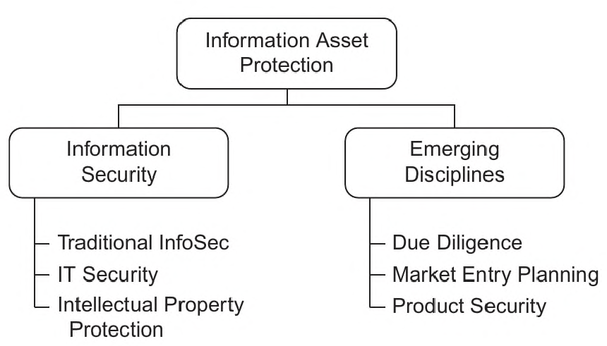Information security includes traditional information protection measures such as marking, storage, proper transmission, and destruction of information. It also encompasses information technology (or IT) security to protect automated information systems, hardware, software, and the data being stored, processed, or transmitted through them. The third element of information security involves the protection of intellectual property rights (IPR).

Similarly, the U.S. Department of Defense defines information security as "the system of policies, procedures, and requirements established ... to protect information that, if subjected to unauthorized disclosure, could reasonably be expected to cause damage...." The same document defines information as "Any knowledge that can be communicated or documentary material, regardless of its physical form or characteristics, that is owned by, produced by or for, or is under the control of [an enterprise]..." (Department of Defense, 1997).

The emerging disciplines complement information security and include the conduct of due diligence investigations as a vetting tool (to establish an appropriate level of trust with potential partners, vendors, contractors, and other third parties). They also include the practice of market entry planning and product security (ASIS International and IAP Council, 2009). These topics will be discussed later in this chapter.

Information assets protection brings these disciplines and elements together in a concerted way and provides a comprehensive approach to maintaining the value of information and intangible assets.

Intangible Assets — these are assets of any organization (including companies and government agencies) that are not physical in nature. Examples of intangible assets are an organization's reputation, brand, relationships, management style, knowledge, and processes. Intangible assets are generally very difficult to measure or quantify — and may often be overlooked when determining where to apply security or protection efforts.

Competitive Intelligence versus Economic Espionage — although both of these methods involve collecting information for the ultimate purpose of supporting business or government objectives, they represent opposite ends of a spectrum of "ethicalness." Competitive intelligence is a normal business function which can include completely benign activities such as market research. As competitive intelligence measures become more aggressive, they may approach a "gray area" in the center of the spectrum that borders on unethical behavior. This includes activities like making pretext phone calls (or e-mails) to competitors to gather information, or sending individuals to pose as job applicants. Industrial or economic espionage is on the other end of the spectrum and includes illegal activities such as electronic eavesdropping and hiring employees away from competitors for the specific purpose of gaining confidential information (Webster University, 2008).

Compromise — Refers to a situation where sensitive, controlled, or classified information actually falls into the hands of an unauthorized person or organization. This is contrasted with a security violation, for example, in which a policy or procedure was not followed but there is no indication that any information was actually lost.

Counterintelligence — any measures taken to negate intelligence collection efforts against an organization or its people. In the federal sector, counterintelligence relates to programs designed to counteract foreign intelligence services and recruited agents. In the private sector it is often referred to as "counter competitive intelligence" and may be focused on protecting against actions ranging from simple market research up to and including industrial espionage. The term is also used in the law enforcement community to refer to actions taken to protect sensitive information from falling into the hands of criminal organizations that may be targeting law enforcement agencies, personnel, or task forces. Counterintelligence activities may be defensive or offensive in nature, and may also be primarily proactive or reactive.

Information Security — (see paragraph on Information Assets Protection)

Sensitive Information — Information or knowledge that might result in loss of an advantage or level of security if disclosed to others (ASIS International, Information Asset Protection Guideline, 2007, p. 8).

Technical Security — Measures taken to identify, prevent, or neutralize technical threats including electronic or electro-optic eavesdropping, wiretapping, bugging, signal intercept, covert /illicit surveillance, and attacks on information technology or telecommunications systems (ASIS International, Information Asset Protection Guideline, 2007, p. 8).

Technical Surveillance Countermeasures — Also known as TSCM, they include services, equipment, and techniques designed to locate, identify, and neutralize technical surveillance activities such as covert listening devices.

Trade Secret — Trade secrets are defined by laws, such as the Economic Espionage Act, at the federal level, as well as by state and local laws. Generally, trade secrets are designated by the owner, but must meet certain criteria in order to qualify for applicable legal protections. Although the laws vary, most require that information have demonstrable value to the owner, be specifically identified, and be adequately protected in order to qualify as a trade secret.

THREATS TO INFORMATION AND INTANGIBLE ASSETS
As with any asset protection issue, we must consider three categories of threats: intentional, natural, and inadvertent. Like any tangible asset such as a building or piece of equipment, information will be subject to all three categories. Although our primary focus in information asset protection (IAP) is on intentional and inadvertent threats, some attention must also be directed at natural threats. For example, in the wake of Hurricane Katrina (2005), many small businesses failed, not because their facility was destroyed or their people displaced, but because they lost the bulk of their critical business information. It is not uncommon for organizations to prepare their facilities and people for the effects of a natural disaster, while neglecting to take prudent information protection measures.

Preparations such as geographically separated off-site backup or data protection measures for contingency remote computing can mean the difference between successful business recovery and catastrophic failure.

The nature and extent of the threat to information and intangible assets is concisely summarized in the introduction to the economic espionage page on the Federal Bureau of Investigation's (FBI) Web site:

The Cold War is not over, it has merely moved into a new arena: the global marketplace. The FBI estimates that every year billions of U.S. dollars are lost to foreign competitors who deliberately target economic intelligence in flourishing U.S. industries and technologies

The methods that comprise the threat to information assets cover the gamut from old, time-tested techniques to new and innovative collection measures. Among the commonly reported collection methods are:
- Open source collection of public information
- Data mining and /or the use of information brokers
- Social engineering and other elicitation techniques
- Co-opting/recruiting a current or former employee (or trusted third party)
- Hiring key employees away from the targeted organization
- Targeting meetings and conferences
- Electronic eavesdropping
- Theft of hardcopy information
- Theft of softcopy information/ media (e.g., thumb drives, laptop computers, mobile devices, etc.)
- Unauthorized penetration of information systems (e.g., hacking)
- Unauthorized access to information systems by insiders
- Exploitation of joint venture partners or other trusted third parties
- Unauthorized physical access to (or observation of) information
- Misdirected e-mail or other electronic communications
- Deliberate disclosure (e.g., by a disgruntled employee)
- Inadvertent disclosure through errors or by accident
- Inadvertent disclosure through third parties who may not maintain the same security standards that your organization does

One specific threat that is worth mentioning separately is that of laptop computer theft. A recent research report (for the ASIS Foundation) by consultant Glenn Kitteringham, CPP, studied the theft of laptops. The report noted that a 2006 Ponemon Institute survey found that 81% of companies responding reported the loss of one or more laptop computers in the preceding
12 months. Kitteringham's study also mentioned that according to the FBI, 97% of stolen laptops are never recovered (Kitteringham, 2008, p. 5). In a recent interview with the author, Kitteringham mentioned that the original intent of the laptop theft research study was to focus on theft of the hardware, but as he uncovered more information he realized that the real threat in stolen laptops was the loss of the data (or information assets) they contained. This changed the direction of his research and resulted in a conclusion that information protection measures were a more immediate need than hardware theft prevention (Kitteringham, 2009).

There is often a controversy over whether the primary source of the threat to information comes from outside the organization or from insiders (employees and others with a trusted relationship). Several studies, including a report by the U.S. Secret Service and another one by the Defense Department's Personnel Security Research Center (PERSEREC), conclude that a significant portion of the threat is attributable to insiders. Insiders have some level of authorized access, they know "the system," and they know where to look for valuable information.

According to the 2007 Trends in Proprietary Information Loss Survey Report:

"The largest threats to proprietary information are from those with a trusted relationship with the organization — current and former employees and those partners, outsourced providers, and customers ..." (ASIS International /ASIS Foundation, August 2007, p. 29).

Beyond the question of insider versus outsider, we need to take a look at who our adversaries might be in terms to threats to our information assets. The collectors (or perpetrators) are fairly well defined by the list of methods previously mentioned in this section. However, we should also consider who the "customers" or end users of the information might be. Being able to distinguish between the collector and the end user allows security professionals to develop more effective risk mitigation strategies for information asset protection.

End users may be the same as the collectors, but often are not. Among common end users for compromised information assets are:
- Domestic and foreign competitors
- Foreign governments
- Organized criminal enterprises
- Information brokers
- Activist groups (environmental, animal rights, monetary rights, ant capitalist, etc.)
- Terrorist groups
- Political advisors
- Quasi-government groups
- Financial or business cartels
- Product counterfeiting operations
- Targets of law enforcement activities

HOW TECHNOLOGY IS CHANGING THE THREAT
Today technology is moving and advancing at an amazing pace. This results in wonderful opportunities for information sharing, productivity, and accomplishment, but it also represents a new paradigm for security risks. In some ways the threat remains unchanged, yet in other ways things are very different.

David Drab sums it up this way in a white paper on the Economic Espionage Act (EEA):

The motives and tactics have remained constant over the years — economic gain, competition, career recognition, and vengeance. However, the methods used to collect and transmit information have significantly changed as a result of high technology, the World Wide Web, and worldwide telecommunications (Drab, August 2003, p. 2).

One result of changing technology is that the traditional reaction to an information compromise - containment - essentially becomes obsolete. Previously, when a privileged hardcopy document was inadvertently (or intentionally) disseminated to unauthorized recipients, the immediate reaction was to attempt to retrieve the copies — and hopefully get them all back. This concept no longer works in our 21st-century interconnected world.

As the 2007 ASIS report on the Trends in Proprietary Information Loss Survey puts it:

[We need to recognize the] reality of "speed" at which valuable information-based assets can be acquired and disseminated globally. Once the asset is gone or compromised, containment — in the conventional sense — is seldom a realistic option.

The consequences in terms of lost economic/competitive advantage can be extremely quick and long lasting (ASIS International /ASIS Foundation, 2007, p. 41).

In other words, once information is lost, it is lost permanently and globally — and that can
happen instantaneously! As security professionals, we need to recognize this fact.

Other technological factors affecting the risk environment for information assets include:

Miniaturization of Media — More and more data is being stored on smaller and smaller devices. Not only can huge amounts of data be stored, but today we can even build an entire computing environment on a flash drive.

Social Networking Media — Sites such as Facebook, MySpace, and Twitter are growing in popularity each day. Although they are extremely popular among almost all demographics, they also have security risk implications. For example, this type of media provides another outlet for instantly sharing information (including possibly sensitive/proprietary information or destructive false rumors) across wide audiences — and in some cases, anonymously. The threat of an unhappy employee posting damaging information in an angry rage (before thinking about the implications or having the opportunity to calm down and regain a rational state) is a growing concern for organizations of all types — and as mentioned: once it's gone it's gone.

Volume and Dispersal of Data — The enormity of the current volume of data makes it far more difficult in many cases to identify a data breach in real time or to determine if sensitive information has been compromised.

Data Mining and Information Brokers — Emerging threats to sensitive information worldwide. A cottage industry is growing up around the mass collection of data from a multitude of sources and selling it to whoever is willing to pay for it. Modern software tools are available to "mine" (search and collect) information continuously from databases, repositories, archives, Web sites, and other sources.

Additional software tools can sort, collate, and analyze data to easily and quickly generate a useful — and very valuable — product on any subject requested. In essence, this is automated intelligence gathering — and it is happening every day and everywhere. It represents a significant threat to information assets in both the public and private sector.

Wireless and Remote Computing Environments — These expose new vulnerabilities as sensitive information can be exchanged through hot spots in public locations, hotel networks, or even home networks. This issue becomes increasingly relevant as more employees participate in telecommuting and /or stay connected while away from the office.

Security of Security Systems — is a growing concern as security systems for surveillance, access control, facility management, intrusion detection, and other functions increasingly ride on the Internet and can be managed remotely (including on mobile devices). The following quote from a research report on this topic is eye-opening to many protection professionals:

... a general trend to open architectures across TCP/IP-enabled networks, has resulted in new, serious security risks that are often overlooked. Few individuals realize, for example, that closed circuit cameras are misnamed in that they are no longer "closed" from a networking standpoint. When these special systems and devices are connected to organizations' networks, they often introduce a multitude of new, previously unanticipated security risks (Alliance for Enterprise Security Risk Management, 2006, pp. 9-10).

A SUITE OF PROTECTIVE MEASURES
Effectively protecting information and intangible assets presents special challenges, but like any asset protection situation, warrants a well thought-out strategy that comprises a suite of countermeasures. The measures employed to protect information assets fall into three categories: security, legal, and management.

Security Measures
The following list represents a sampling of security measures that are typically applied to the task of protecting information and intangible assets.
- Assessment (possibly including penetration testing or "red teaming")
- Need-to-know controls
- Information storage and handling
- Physical security (surveillance, access control, intrusion detection)
- Visitor control and escort procedures
- Design and layout of facility (controlled versus open/public areas)
- Security officers /response forces
- Information destruction
- Technical security measures
- TSCM
- Communications, emanations, and signals security measures
- Information systems security (IT security)
- Product security
- Travel security programs
- Training and awareness (for employees, users, contractors, vendors, partners, and trusted third parties)
- Investigation capabilities

Many of these are standard security measures which are in place and protect all types of assets: people, property, and information. Other measures are more specific to information protection. Our challenge is to effectively leverage the standard security measures while identifying and implementing those specific measures that support the information asset protection strategy. While there are a variety of sources (including other chapters of this book) for details on these countermeasures, a few of the items listed above warrant some brief discussion here.

Training and awareness are absolutely essential tools. They must be delivered using a variety of media (classroom programs, computer-based training, computer screen banners, newsletters, intranet resources, and others) on a regular basis in order to keep the subject in the forefront of protection officers' minds. As the Information Asset Protection Guideline mentions:

.security awareness and training is one of the most cost effective measures that can be employed to protect corporate and organizational information assets.

. . . Where each individual entrusted with sensitive information takes prudent measures and personal responsibility for protecting those assets, a robust security environment should occur naturally (ASIS International, IAP Guideline, 2007, p. 14).

Another strong recommendation for all organizations is that elements of information asset protection be incorporated into due diligence assessments (investigations) for mergers, acquisitions, joint ventures, partnerships, and other key business transactions. This will aid immeasurably in anticipating risks that will or may present themselves after the fact.

Finally, product security technologies including embedded electronic article surveillance, various packaging innovations, RFID, and serialization techniques are, by necessity, becoming commonplace.

Some measures will be reactive rather than proactive. When an information loss is known or suspected, conduct an investigation to support a damage assessment as well as any possible law enforcement, litigation, or asset recovery actions. The results of the investigation should also reveal the root cause of the compromise and be used to implement corrective actions and prevent future occurrences (ASIS International, 2008, p. 2-1-29).

Legal Measures
Beyond their deterrent value, most legal measures are reactive in nature. Nonetheless, they are an important element of the information asset protection strategy. Patents, copyrights, and trademarks are common legal tools in protecting highly valuable information. Another tool is that of a "trade secret," which is generally considered to be the most restrictive or protective measure. Trade secrets have the advantage of not requiring registration but are subject to strict interpretation in court with respect to the need to identify, determine value, and adequately protect the information. The high legal standard of "adequate protection" often supports the use of robust security measures within an organization — which is a welcome situation from a security perspective.

For these legal means to be useful, however, the organization must be willing to enforce the tools in a court of law. This can be a very resource-intensive ordeal, particularly in terms of time, effort, and cost. These are decisions that must be made at the executive level and shared with key players in the organization such as the security and legal departments.

Other legal measures include contract clauses, third party agreements, and possibly even performance incentives for vendors, partners, and joint venture participants. Information and intellectual property protection is a highly specialized discipline and organizations should obtain support from a qualified legal advisor/ firm rather than relying on a generalist or local general counsel.

An important tool in protecting information assets is the 1996 Economic Espionage Act (EEA). This is a very relevant piece of legislation as it makes the theft of intellectual property a federal offense and allows the FBI to investigate such cases even if a foreign intelligence service is not involved.

A white paper on the EEA reads:

[Recognizing that] trade secrets are the lifeblood of most process-driven companies ... it naturally follows . . . that organizations that fail to safeguard their intellectual assets lose ground.

The Economic Espionage Act . . . [prohibits] misconduct regarding trade secrets . . . [including anyone who] steals or obtains [trade secret information] by fraud or deception.

The law includes the following as prohibited activities with respect to trade secrets and related information: anyone who "copies, duplicates, sketches, draws, photographs, downloads, uploads, alters, destroys, photocopies, replicates, transmits, delivers, sends, mails, communicates, or conveys such information." A violator can also be someone who " [knowingly] receives, buys, [or] possesses" information (Drab, August 2003, p. 4).

This is a very forward-thinking law that can and has been applied effectively to resolve trade secret and intellectual property cases in many industry sectors.

Management Measures
An interesting study by the U.S. Secret Service looked at threats to information assets by analyzing a number of specific cases. It focused on "insider" threats and reported some relevant results. In 80% of the cases studied, the perpetrator had come to the attention of management due to inappropriate behaviors before the incident (e.g., tardiness, truancy, arguments with coworkers, or poor job performance) (U.S. Secret Service, 2005, p. 15). This highlights the importance of "management measures" as part of an overall information asset protection strategy.

Other management measures that should be considered, and generally be coordinated with the security program, include effective employee screening (pre-employment and periodic), drug screening, establishing relevant policies and procedures, and offering a reporting mechanism that allows employees and others to provide information (and make allegations). When using a reporting mechanism such as an employee hotline, be sure that the organization is responsive to calls and allegations. Otherwise, the hotline will soon lose its effectiveness, and important reports will be missed.

The FBI offers some recommendations on their economic espionage Web page. They present six steps to protect your business from espionage — and all are worth considering. They are:

- Recognize there is a real threat.
- Identify and evaluate trade secrets.
- Implement a definable plan for safeguarding trade secrets.
- Secure physical trade secrets and limit access to trade secrets.
- Confine intellectual knowledge.
- Provide ongoing security training to employee

As indicated, it is important — in any private or public sector setting — to find the proper balance between legal protections and security protections.
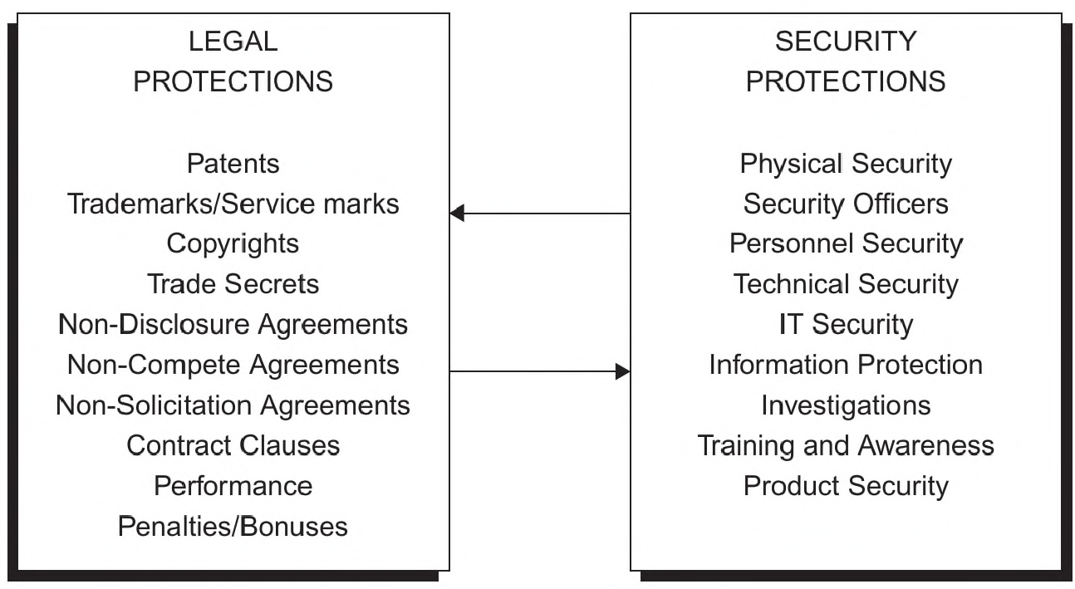
To achieve protection objectives and ensure they are consistent with the business or organization's strategic goals, these two "communities" of protection measures should work together to develop an integrated risk mitigation approach. Working in a vacuum can result in duplication of effort and significant waste as well as poor results due to internal conflicts.

Finally, according to well-respected consultant and author Ira Winkler, the best approach to addressing risks to information assets is to apply defense in depth (layered security) by incorporating both IT and traditional protection measures. Even if one or a few layers fail, other layers will back up the ones that were unsuccessful. As Winkler puts it, when we apply defense in depth, "security [isn't] perfect, but it [is] prepared" (Winkler, 2005, p. 305)

Examples of some of those "layers" might be strong password protection, encryption, biometric authentication, physical security measures, personnel screening, attended facility access (security officers), employee training, and password-protected screensavers.

The most effective protection officers are those who know their customer (the organization they serve) and tailor the way they provide security services to the customer's mission and culture.
In many organizations, information assets are absolutely crucial to the survival and success of the enterprise. Officers should recognize this aspect of the organization and factor it into the performance of their protection duties. It should be noted that many contemporary companies are centered on information as their core business function, hence our "information-based society." It is our responsibility to remember that a key objective of information asset protection is to enable core business functions, rather than present obstacles. As the past Chairman of the
ASIS Information Asset Protection Council puts it, "The ultimate objective is to enable business.
Security's role is to help organizations assess and address risk to enable 'smart' business transactions" (Heffernan, 2007).

In general, professional protection officers place most of their emphasis on protecting people and property, but it is important to support the third asset category as well: information.
Elements of information asset and intellectual property protection should be included in officer and supervisor training, as well as quality assurance standards for security programs.

Security service providers should consider adding information asset protection services to their suite of protective service offerings. This might include conducting information protection assessments, specialized protection services, courier services, or other tools focused on this category of asset.
EMERGING TRENDS

Three emerging issues that are relevant to the protection of information and intangible assets are the increasingly interconnected global business environment, the rapid advances in information technology, and the fact that we now have to consider — in a different way — the security of security systems. These issues are discussed in this chapter, but need to be constantly reviewed due to the unprecedented pace of change in today's security environment.

The advances in information technology have a number of implications. One is the new family of risks that are introduced by drastically increased use of information technology in business, organization, government, and home settings. As such use and popularity increases, systems and the data residing on them become more attractive targets for a variety of adversaries.

These new technology tools can also be exploited by adversaries to support their illicit activities. The best examples at the moment are the new cottage industry of information brokers and the use of sophisticated data-mining tools and techniques to target sensitive information. This trend will expand in the future and newly introduced business tools such as cloud computing and wireless technologies will likely be "abused" by bad actors for nefarious activities.

SUMMARY
Studies have concluded that as much as 75% or more of a company's value may lie in information and intangible assets (Moberly, 2007). Since these assets are the most difficult to identify, measure, and control, they deserve a great deal of attention from a risk management perspective. Following a thorough risk assessment, an orchestrated suite of security, legal, and management solutions should be applied to the identified organizational risks. The mission and culture of the organization (customer) should be factored in to the services provided and the manner in which they are delivered and managed.

Protection officers play a key role in the protection of information and intangible assets. In fact, they can even influence the reputation of an organization by presenting a highly competent and professional image and by acknowledging the nature of the assets (including information assets) they are responsible for protecting.

Through conscientious IAP practices, organizations will be better prepared to deal with today's broad array of threats ranging from competitive intelligence and industrial espionage, to cyber attacks, to counterfeiting and product piracy (ASIS International and IAP Council, 2009).

SECURITY QUIZ

- Computer security, information security, and information technology (IT) security all mean the same thing and are interchangeable terms.
- True
- False

- Counterintelligence is an important function and can be applied in private sector companies as well as in government agencies.
- True
- False

- Legal measures are generally "reactive" rather than "proactive" in nature.
- True
- False

- According to consultant Michael Moberly, approximately what percentage of a company's value generally lies in information and intangible assets?
- 90%
- 50%
- 10%
- 75%

- The practice of asset protection focuses on which categories of "assets"? (Circle all that apply.)
- Information
- Physical
- People
- Property

- Which of the following is NOT a characteristic of the Economic Espionage Act of 1996?
- It makes it a federal crime to steal trade secrets
- It is a forward-looking piece of legislation
- It includes "altering" information as a prohibited act
- It must be updated every 5 years

- According to this chapter, the field of "information security" includes:
- Competitive intelligence
- IT security
- Intellectual property protection
- Traditional information security

- When an information loss is known or suspected, the following actions should be taken:
- Corrective actions
- Damage assessment
- Containment
- Determine root cause

- Information that is lost is not permanently lost
- True
- False

- An important tool in protecting information assets is the Economic Espionage Act (EEA)
- True
- False

